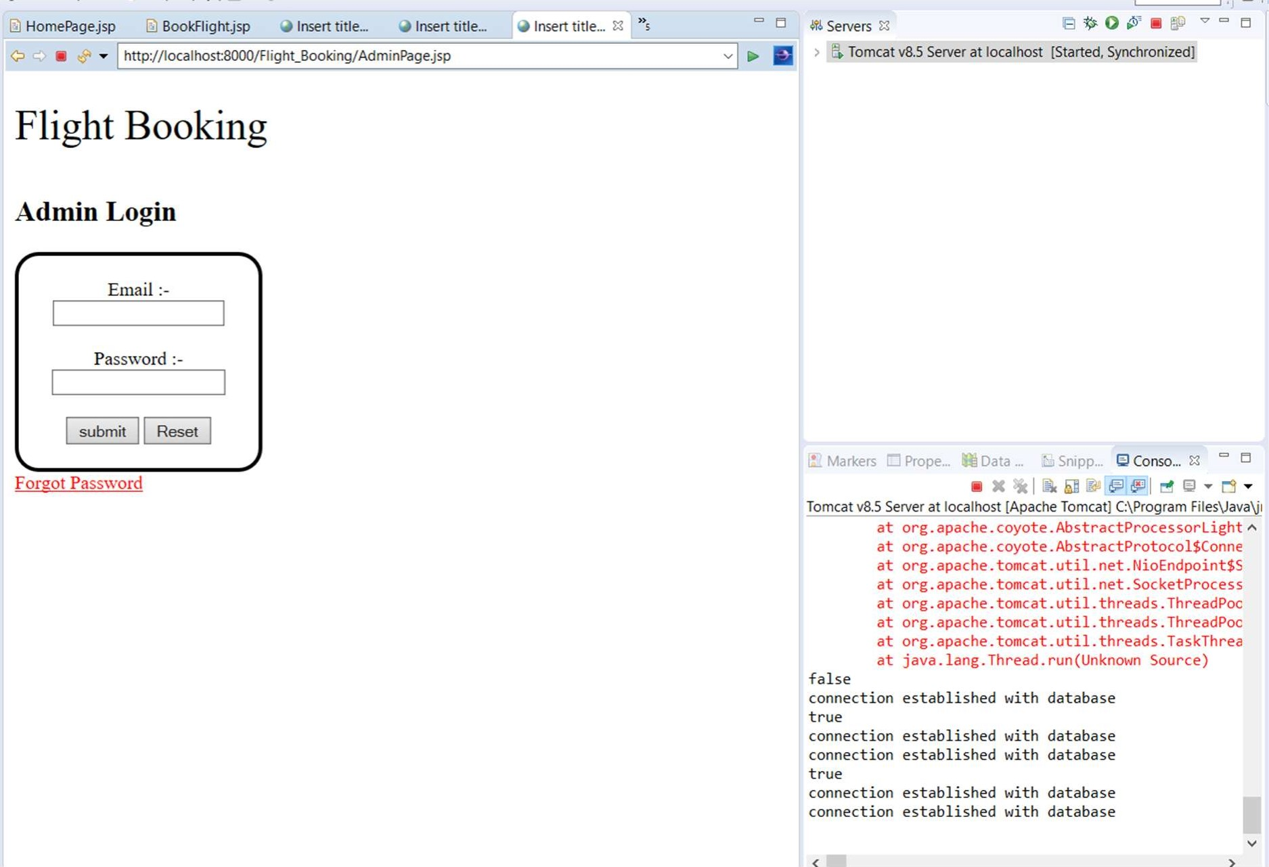Tomcat v8.5 Server at localhost [Apache Tomcat] C:\Program at org.apache.coyote.AbstractProcessorLight at org.apache.coyote.AbstractProtocoI$Conne at org.apache.tomcat.util.net.NioEndpoint$S at org.apache.tomcat.util.net.SocketProcess at org.apache.tomcat.util.threads . ThreadPoc at org.apache.tomcat.util.threads.ThreadPoc at org.apache.tomcat.util.threads.TaskThrea at java. lang. Thread. run(Unknown Source)

connection established with database

connection established with database connection established with database

connection established with database connection established with database

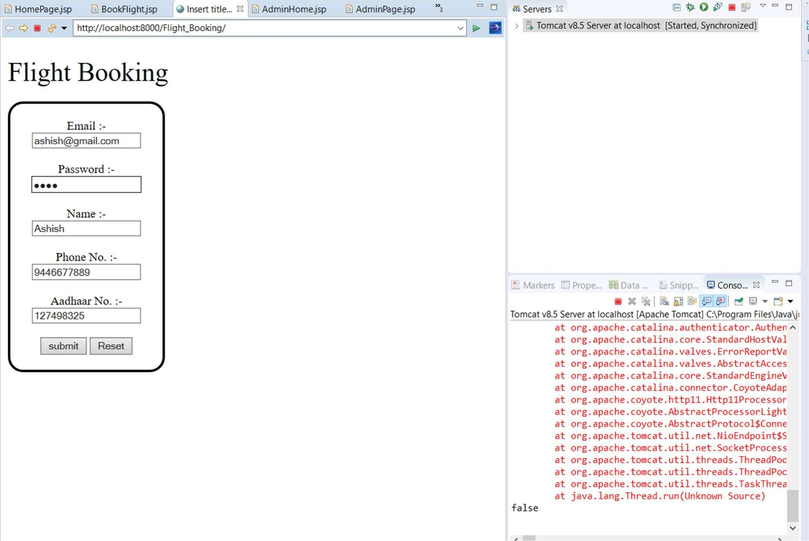

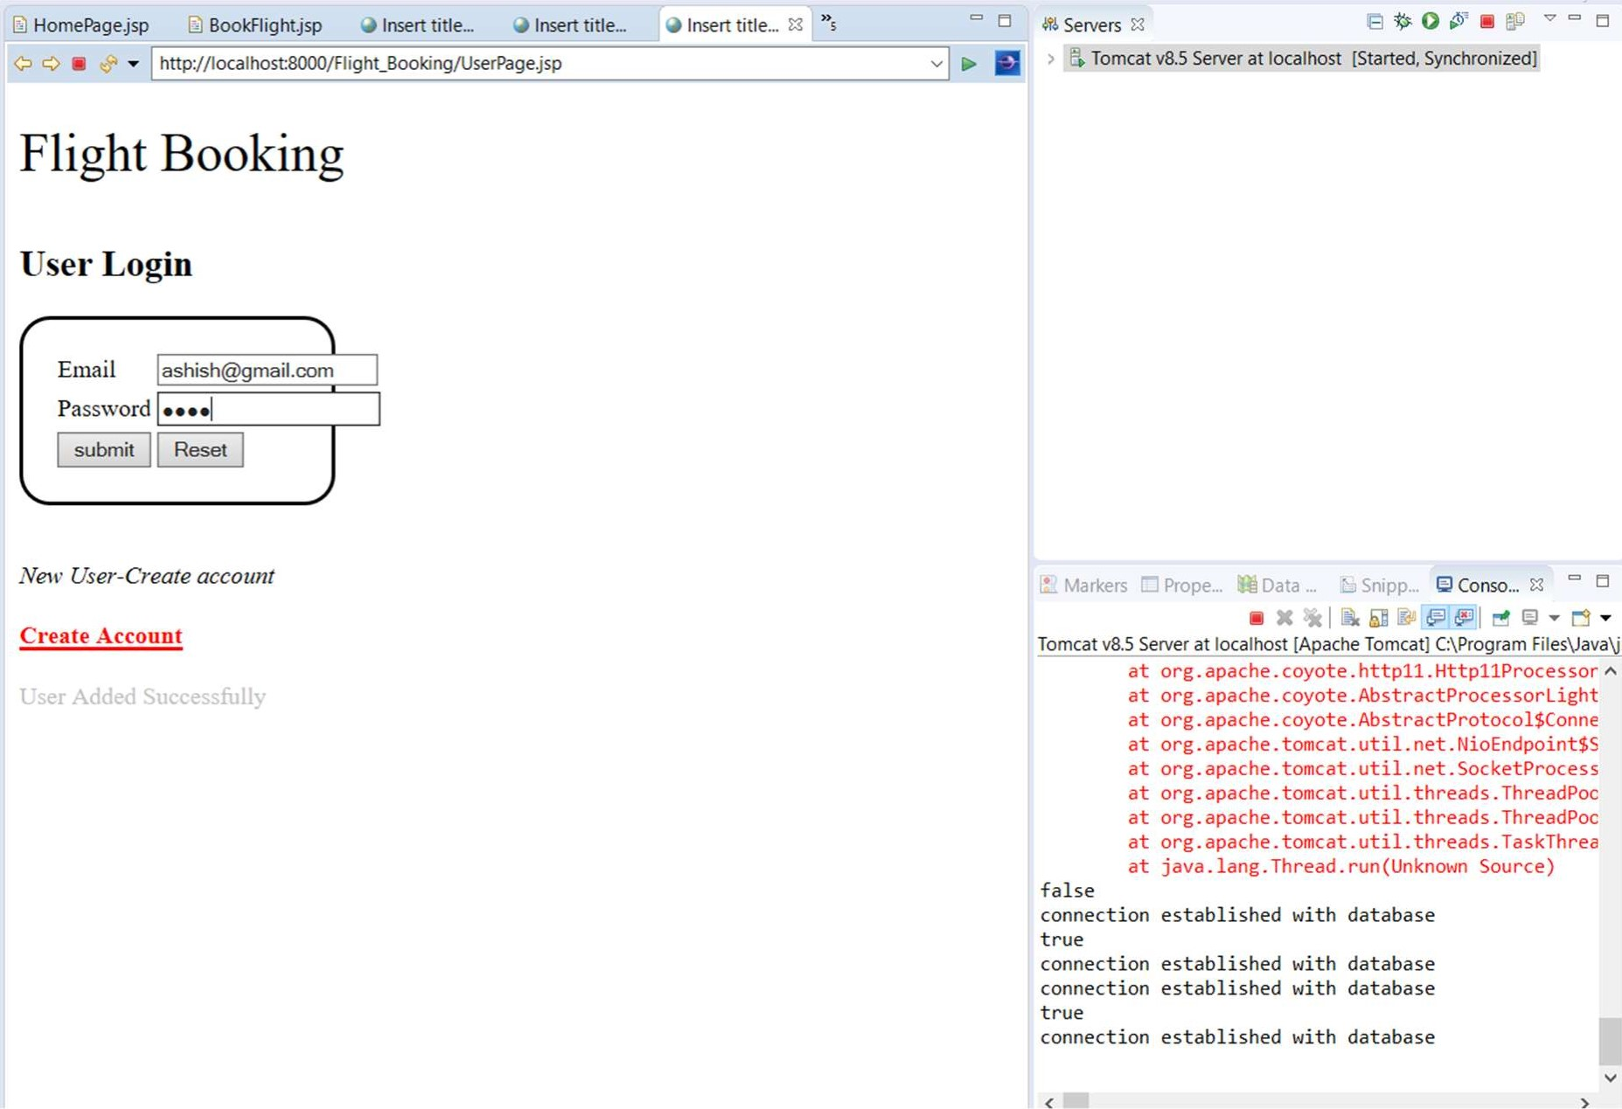 .. Snipp... Conso...

with database

with database with database

with database

|  |  |  |
| --- | --- | --- |
| HomePage.jsp BookFlight.jsp Insert Insert | Insert |  |
| http://localhost:8000/Flight_Booking/HomePage.jsp  FlyAway  Welcome Ashish  Logout | Admin Login | |

> Tomcat v8.5 Server at localhost [Started, 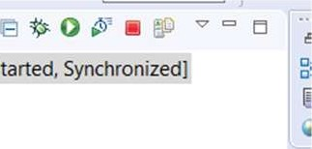Synchronized)

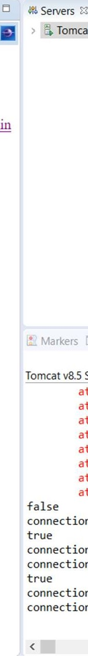

at

at

at

at

at

at

at

at

connection

connection

connection

connection

connection

Markers Prope... Data

Tomcat v8.5 Server at localhost [Apache Tomcat] C:\Program Files\Java\jl org.apache.coyote.AbstractProcessorLight org.apache.coyote.AbstractProtocoI$Conne org.apache.tomcat.util.net.NioEndpoint$S org.apache.tomcat.util.net.SocketProcess org.apache.tomcat.util.threads.ThreadPoc org.apache.tomcat.util.threads.ThreadPoc org.apache.tomcat.util.threads.TaskThrea java. lang. Thread. run(Unknown Source) established with database

established with database established with database

established with database established with database 

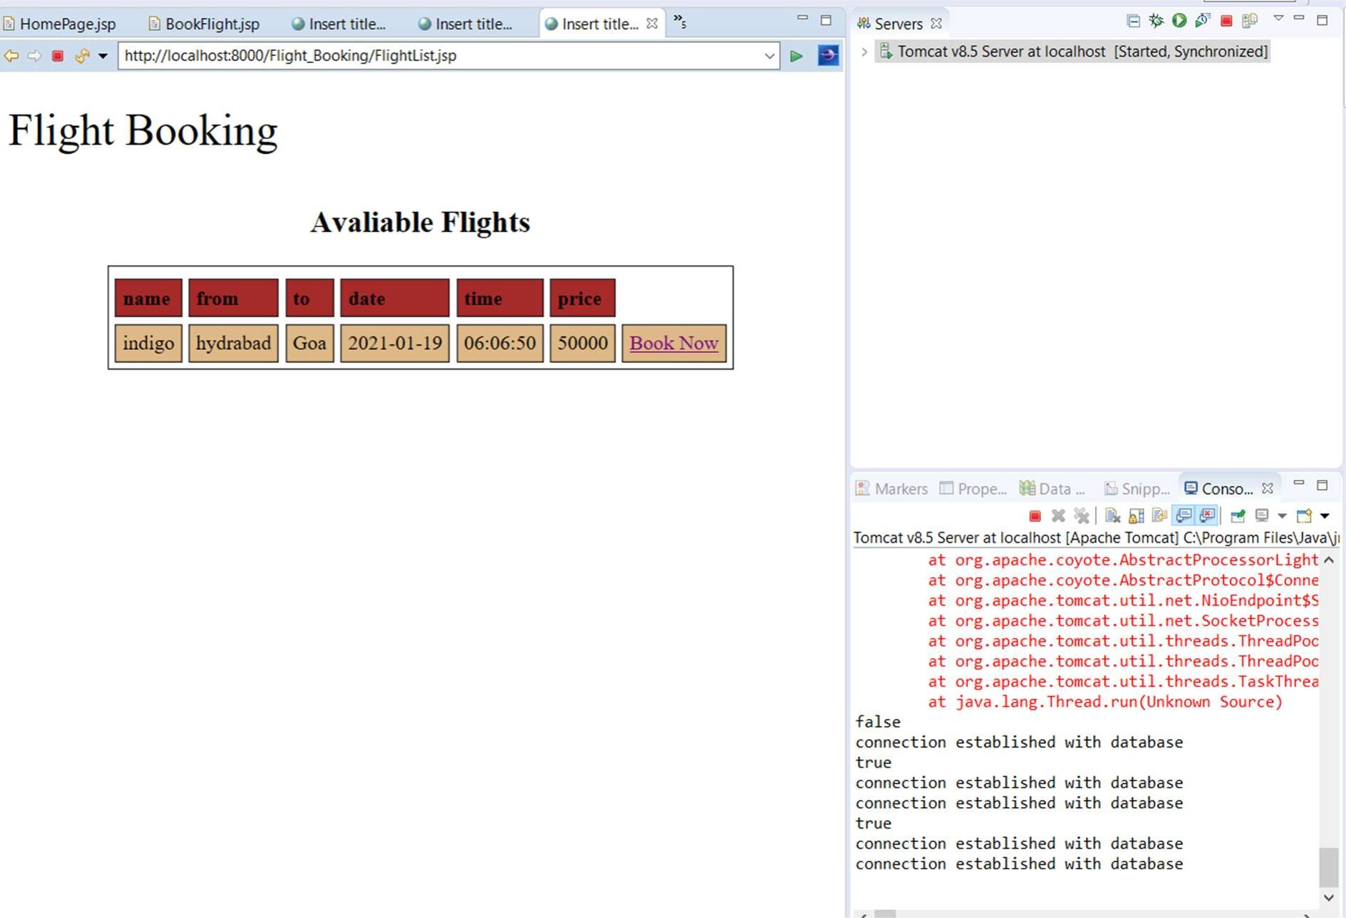 ... E Snipp... Conso.„

at at at at at at at at

connection with database

connection with database connection with database

connection with database connection with database

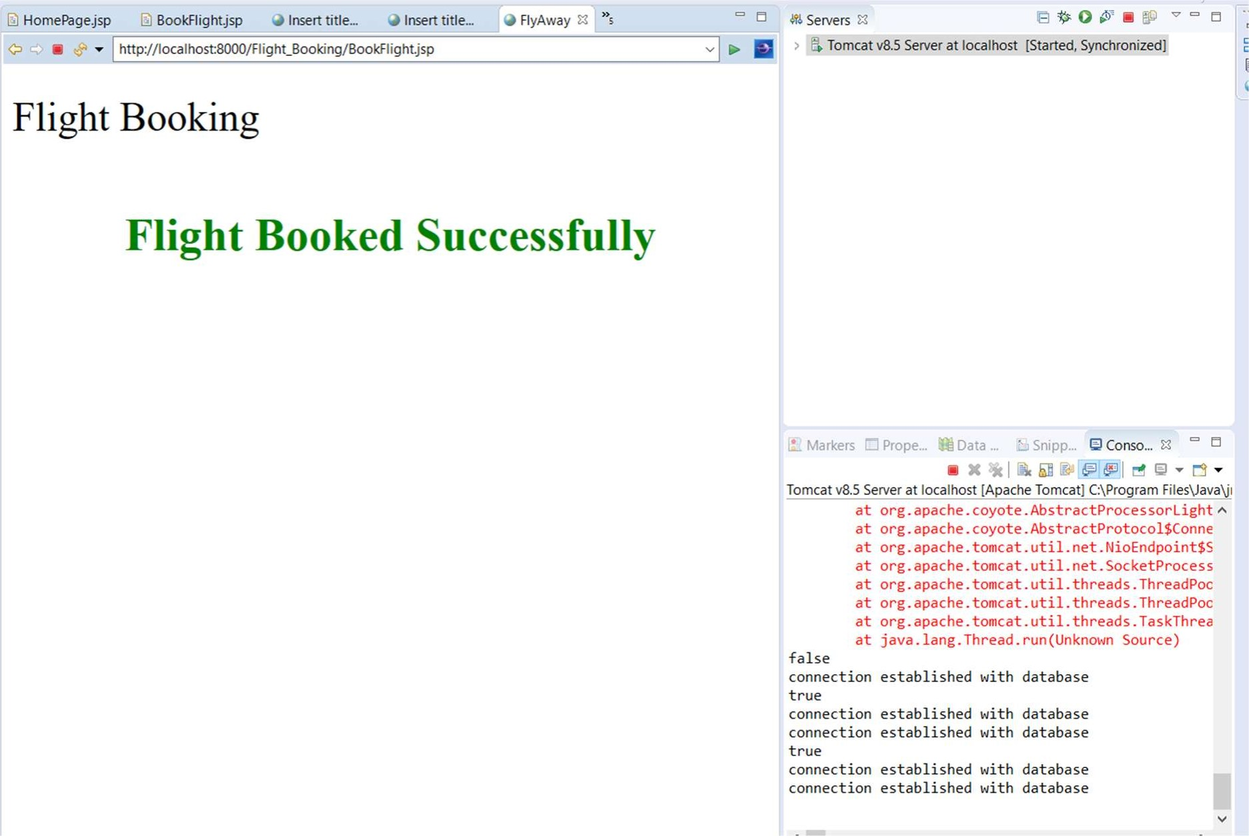

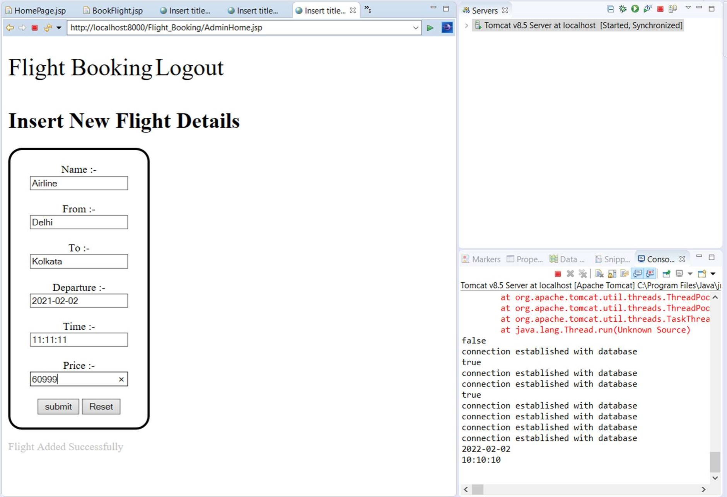

E Markers Prope... Data ... Snipp... Conso...

at java. lang. Thread. run(Unknown Source) false connection established with database true connection established with database connection established with database true connection established with database connection established with database connection established with database connection established with database 2Ø22-Ø2-Ø2 connection established with database

2Ø21-Ø2-Ø2

11:11:11